

Semester Two Examination, 2018

Question/Answer booklet

MATHEMATICS

SOLUTIONS
METHODS
UNITS 3 AND 4

Section One:

Calculator-free

Student number: In figures

In words

Your name

Time allowed for this section
Reading time before commencing work: five minutes
Working time: fifty minutes

Materials required/recommended for this section
To be provided by the supervisor
This Question/Answer booklet
Formula sheet

To be provided by the candidate
Standard items: pens (blue/black preferred), pencils (including coloured), sharpener,
correction fluid/tape, eraser, ruler, highlighters

Special items: nil

Important note to candidates
No other items may be taken into the examination room. It is your responsibility to ensure that you do not have any unauthorised material. If you have any unauthorised material with you, hand it to the supervisor before reading any further.

Structure of this paper

Section | Number of questions available | Number of questions to be answered | Working  time (minutes) | Marks available | Percentage of examination
Section One:  Calculator-free | 8 | 8 | 50 | 52 | 35
Section Two:  Calculator-assumed | 13 | 13 | 100 | 98 | 65
 |  |  |  | Total | 100

Instructions to candidates

1. The rules for the conduct of examinations are detailed in the school handbook. Sitting this examination implies that you agree to abide by these rules.

2. Write your answers in this Question/Answer booklet.

3. You must be careful to confine your response to the specific question asked and to follow any instructions that are specified to a particular question.

4. Supplementary pages for the use of planning/continuing your answer to a question
have been provided at the end of this Question/Answer booklet. If you use these pages to continue an answer, indicate at the original answer where the answer is continued, i.e. give the page number.

5. Show all your working clearly. Your working should be in sufficient detail to allow your answers to be checked readily and for marks to be awarded for reasoning. Incorrect answers given without supporting reasoning cannot be allocated any marks. For any question or part question worth more than two marks, valid working or justification is required to receive full marks. If you repeat any question, ensure that you cancel the answer you do not wish to have marked.

6. It is recommended that you do not use pencil, except in diagrams.

7. The Formula sheet is not to be handed in with your Question/Answer booklet.

Section One: Calculator-free 35% (52 Marks)
This section has eight (8) questions. Answer all questions. Write your answers in the spaces provided.

Working time: 50 minutes.

Question 1 (6 marks)
The shaded region $R$, shown on the graph below, is bounded by the curve $y=e^{3x}$ and the lines $y=0, x=0$ and $x=a$.

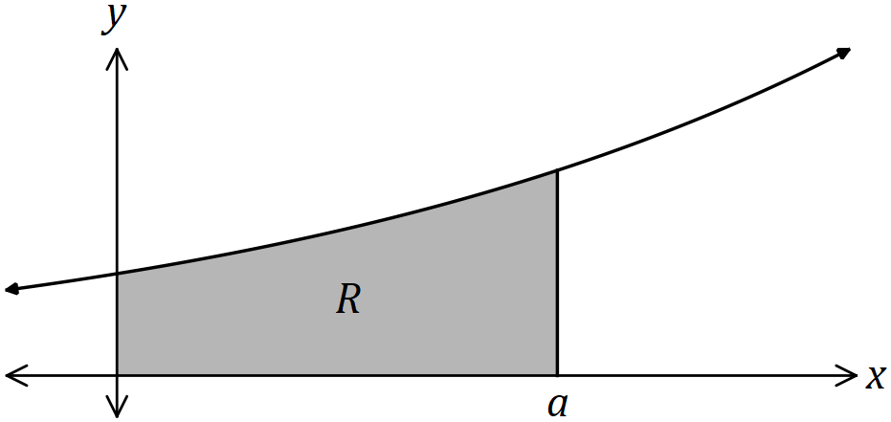

(a) Determine the area of $R$ in terms of $a$. (3 marks)
Solution
$$R=\int_{0}^{a}{e^{3x}}dx \\ ={\left[\frac{e^{3x}}{3}\right]}_{0}^{a} \\ =\frac{e^{3a}}{3}-\frac{e^{0}}{3}=\frac{e^{3a}}{3}-\frac{1}{3}$$

Specific behaviours
✓ writes correct integral
antidifferentiates correctly
✓ substitutes and simplifies

(b) Determine, in simplest form, the value of $a$ for which the area of $R$ is $21$ square units.
(3 marks)
Solution
$$\frac{e^{3a}}{3}-\frac{1}{3}=21⇒e^{3a}=64$$

$$3a=\ln{64}⇒a=\frac{1}{3}\ln{64}$$

$$a=\ln{\sqrt[3]{64}}=\ln{4}$$

Specific behaviours
isolates $e^{3a}$ term
✓ uses logs to obtain expression for $a$
✓ simplifies

Question 2 (5 marks)
(a) Simplify $\log_{2}{(16)}÷\log_{5}{({125}^{2})}$. (2 marks)

Solution
$$\frac{{\log_{2}{2}}^{4}}{\log_{5}{5^{6}}}=\frac{4}{6}=\frac{2}{3}$$

Specific behaviours
expresses as powers of log bases
✓ simplifies

(b) Solve the equation $\ln{(4-x)}+\ln{2}=2\ln{x}$. (3 marks)
Solution
$$\ln\left(8-2x\right)=\ln{x^{2}}$$

$$x^{2}+2x-8=0 \\ \left(x+4\right)\left(x-2\right)=0 \\ x=-4 \text{or} x=2$$

$$\text{But from equation}, 0<x<4$$
$$∴x=2$$

Specific behaviours
writes both sides as single logs
✓ factorises quadratic
✓ identifies just one solution

Question 3 (7 marks)
The graph of $y=2x^{2}e^{-x}$ has one local minimum and one local maximum.

(a) Determine the $x$-coordinates of the stationary points of the graph. (3 marks)
Solution
$$\frac{dy}{dx}=4xe^{-x}+2x^{2}\left(-e^{-x}\right)$$

$$\frac{dy}{dx}=0⇒2xe^{-x}\left(2-x\right)=0$$

$$\text{Hence stationary points when} x=0, 2$$

Specific behaviours
uses product rule correctly
✓ factorises derivative
✓ states $x$-coordinates

(b) Use the second derivative test to determine which of the points from (a) is a local maximum and state the coordinates of this point. (4 marks)
Solution
$$\frac{dy}{dx}=e^{-x}(4x-2x^{2})$$

$$\frac{d^{2}y}{dx^{2}}=-e^{-x}\left(4x-2x^{2}\right)+e^{-x}\left(4-4x\right)$$

$$x=0⇒\frac{d^{2}y}{dx^{2}}=0+4⇒\text{Minimum}$$

$$\text{Hence maximum at} x=2$$

$$\text{Max at} \left(2,\frac{8}{e^{2}}\right)$$

Specific behaviours
second derivative using product rule
✓ substitutes an $x$-value
✓ interprets sign of second derivative
✓ deduces required $x$-value and states coordinates

Question 4 (6 marks)
The random variable $X$ has probability density function

$$f\left(x\right)=\left\{\begin{matrix}k{\left(\frac{x}{4}-1\right)}^{3}, & 4≤x≤12 \\ 0, & \text{elsewhere.}\end{matrix}\right.$$

(a) Determine the value of the constant $k$. (4 marks)
Solution
$$k\int_{4}^{12}{{\left(\frac{x}{4}-1\right)}^{3}}dx=1$$

$${\int_{4}^{12}{{\left(\frac{x}{4}-1\right)}^{3}}dx=\left[{\left(\frac{x}{4}-1\right)}^{4}\right]}_{4}^{12}$$
$$=2^{4}-0^{4}=16$$

$$16k=1⇒k=\frac{1}{16}$$

Specific behaviours
writes integral with correct limits
✓ integrates correctly
✓ equates integral to $1$
✓ correct value of $k$

(b) Write down the cumulative distribution function $F\left(t\right)=P(X≤t)$ for $4≤t≤12$ and hence determine $P(X≤8)$. (2 marks)
Solution
$$F\left(t\right)=\frac{1}{16}\int_{4}^{t}{{\left(\frac{x}{4}-1\right)}^{3}}dx=\frac{1}{16}{\left(\frac{t}{4}-1\right)}^{4}$$

$$F\left(8\right)=\frac{1}{16}$$

Specific behaviours
correct $F\left(t\right)$
✓ correct probability

Question 5 (6 marks)
(a) Determine the anti-derivative of $\begin{matrix}\cos{(3x)} \\ \overline{5+\sin{(3x)}}\end{matrix}$. (2 marks)

Solution
$$f\left(x\right)=\frac{1}{3}\int{\frac{3\cos{3x}}{5+\sin{3x}}}dx \\ =\frac{1}{3}\ln\left(5+\sin{3x}\right)+c$$

Specific behaviours
writes in form $f^{'}\left(x\right)÷f(x)$
✓ correct integral and constant

(b) Determine $f^{'}\left(x\right)$ when $f\left(x\right)=2x\ln{(5x)}.$ (2 marks)

Solution
$$f^{'}\left(x\right)=2×\ln{(5x)}+2x×\frac{5}{5x} \\ =2\ln{(5x)}+2$$

Specific behaviours
uses product rule correctly
✓ differentiates log term correctly

(c) Evaluate $\int_{0.2}^{1}{\underset{ }{\overset{ }{\left(2 ln{(5x)}+2\right)}}}dx$. (2 marks)
Solution
$${\left[2x\ln\left(5x\right)\right]}_{0.2}^{1}$$

$$=2\ln{5}-0.4\ln{1} \\ =2\ln{5}$$

Specific behaviours
antiderivative
✓ evaluates correctly

Question 6 (8 marks)
Right-triangle $T$ has vertices $\left(0, 0\right), (p, 0)$ and $\left(0, q\right)$ where $p>3$ and $q>5$.

The straight line from $(p, 0)$ to $(0, q)$ passes through the point $(3, 5)$.

(a) Sketch a diagram to show this information. (1 mark)
Solution
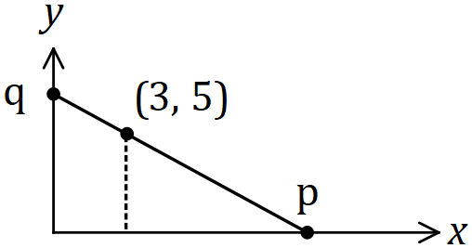

Specific behaviours
triangle with point, $p$ and $q$

(b) Show that the area of the triangle is $\begin{matrix}5p^{2} \\ \overline{2(p-3)}\end{matrix}$. (3 marks)
Solution
$$\text{Similar triangles}: \frac{q}{p}=\frac{5}{p-3}⇒q=\frac{5p}{p-3}$$

$$A=\frac{1}{2}pq=\frac{1}{2}p\left(\frac{5p}{p-3}\right)=\frac{5p^{2}}{2\left(p-3\right)}$$

Specific behaviours
uses ratio of sides
✓ expresses $q$ in terms of $p$
✓ uses area of triangle

(c) Determine the value of $p$ that minimises the area of the triangle and state the minimum area. (4 marks)
Solution
$$\frac{dA}{dp}=\frac{\left(10p\right)\left(2p-6\right)-\left(5p^{2}\right)\left(2\right)}{4{\left(p-3\right)}^{2}}$$

$$\frac{dA}{dp}=0⇒20p^{2}-60p-10p^{2}=0$$

$$10p\left(p-6\right)=0⇒p=6 (\text{since} p>3)$$

$$A=\frac{5\left(6^{2}\right)}{2(3)}=30 \text{sq. units}$$

Specific behaviours
uses quotient rule correctly
✓ equates numerator equal to $0$
✓ solves for $p$
✓ calculates area

Question 7 (6 marks)
The time, $t$ years, to repay a loan of $\$57 000$ at $8.4\%$ interest with monthly repayments of $x$ dollars can be approximated by
$$t=12\ln\left(\frac{x}{x-400}\right), x>400$$

(a) Determine the time to repay the loan when the monthly repayment is $\$600$, simplifying your answer. (1 mark)
Solution
$$t=12\ln\left(\frac{600}{200}\right)=12\ln{3} \text{years}$$

Specific behaviours
substitutes and simplifies

(b) Use the increments formula to estimate the time saved in repaying the loan if the monthly repayment of $\$600$ is increased by $5\%$. (5 marks)
Solution
$$t=12\ln{x}-12\ln\left(x-400\right)$$

$$\frac{dt}{dx}=\frac{12}{x}-\frac{12}{x-400}$$

$${\left.\frac{dt}{dx}\right|}_{x=600}=\frac{12}{600}-\frac{12}{200}=-\frac{24}{600}$$

$$δx=600×0.05$$

$$δt≈-\frac{24}{600}×600×0.05≈-1.2$$
$$\text{Time saved is} 1.2 \text{years}$$

Specific behaviours
✓ uses log laws to simplify $t$
✓ correct derivative
✓ evaluates derivative
indicates value of $δx$
✓ uses increments formula and states time saved

Question 8 (8 marks)
(a) Sketch the graph of $y=\log_{4}{(x-2)}+1$ on the axes below, clearly showing the location of all asymptotes and axes intercepts. (3 marks)

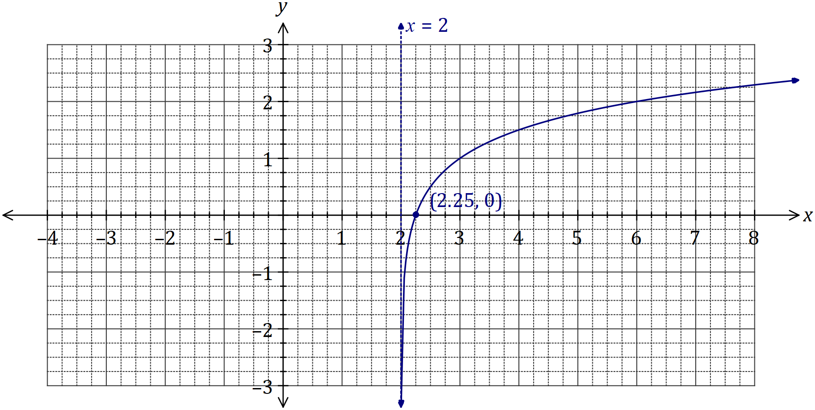
Solution
See graph
Specific behaviours
asymptote
✓ root at $x=2.25$
✓ curve, through $(3,1)$ and $(6, 2)$

(b) Determine the coordinates of the $y$-intercept of the graph of $y=5-\log_{2}{(x+0.125)}$.
(2 marks)
Solution
$$y=5-\log_{2}\left(0.125\right)=5-\log_{2}\left(2^{-3}\right)=5--3=8$$

$$\text{At} \left(0, 8\right)$$

Specific behaviours
simplifies log term to $-3$
✓ states coordinates of intercept

(c) The graph of $y=\log_{a}{(x-a)}$, where $a>1$, passes through $(8.75, 2)$. Determine the coordinates of the root of the graph. (3 marks)
Solution
$$2=\log_{a}\left(8.75-a\right)⇒a^{2}+a-8.75=0$$

$$a=\frac{-1±\sqrt{1+4\left(8.75\right)}}{2} \\ =\frac{-1±6}{2}$$
$$a=2.5, \left(a>1\right)$$

$$\text{Hence root at} (3.5, 0)$$

Specific behaviours
forms quadratic equation
✓ solves for $a$
✓ states coordinates of root

Supplementary page

Question number: _________

© 2018 WA Exam Papers. Baldivis Secondary College has a non-exclusive licence to copy and communicate this document for non-commercial, educational use within the school. No other copying, communication or use is permitted without the express written permission of WA Exam Papers. SN261-125-2.

